**Post Graduate Diploma in Water Hygiene and Sanitation (WASH)**

**WASH Assignment 4**

**Prepared by:**

S. M. Tareq Bin Jamil Neoaz

Email: [tareq.bin.jamil@gmail.com](mailto:tareq.bin.jamil@gmail.com)

Date of Submission: November 16, 2019

**Assignment**

1. List and briefly describe the measures by which the success or otherwise of a public–private partnership providing water supply services can be assessed.

2. Give six possible causes of water emergencies, three due to natural causes and three due to humans.

b. What are the options for safe water supply during a water emergency?

3. You are about to set off to conduct a sanitary inspection of an abstraction point at a river.

1. What would you take with you?
2. Explain four things you will be looking for during your inspection.

4. Explain briefly why a Water Safety Plan is necessary

5. Distinguish between the two types of maintenance at a water utility and give reasons why one of them is better

**1. List and briefly describe the measures by which the success or otherwise of a public–private partnership providing water supply services can be assessed.**

**Answer:**

The performance of a PPP (and indeed a public water utility) can be assessed through the following parameters:

**• *Accessibility*:** the extent of coverage of the population, and the distance to the water point. What proportion of the population have access to water? Is the distance to the water point less than 1 km or 30 minutes’ walking time? Pickering and Davis (2012), using survey data from 26 sub-Saharan countries, found that the further away a water source was, the less water was used; when the distance was more than 30 minutes away, households collected less water than was necessary for basic needs.

**• *Affordability*:** the cost of the water needed should be less than 5% of the household’s income.

**• *Cost recovery*:** the cost of providing the water should be claimed back from the population.

**• *Minimization of non-revenue water*:** this should be reduced to 15% or less.

**• *Water quality*:** the water should meet national standards for quality.

**• *Operational efficiency*:** the quantity of water supplied per capita, and the duration of water supply per day.

**2. Give six possible causes of water emergencies, three due to natural causes and three due to humans.**

**b. What are the options for safe water supply during a water emergency?**

Answer:

A **water emergency**, is an event that disrupts the normal supply of water. It can occur due to natural causes or when there is damage to the major infrastructure of the treatment plant, water storage or water distribution system. Untreated or partially treated water may be inadvertently distributed in an emergency situation. Another cause of a water emergency could be contamination of the water supply, for example by a chemical leak.

There are several different types of emergency that can affect water supply and some of these are described follow.

**Drought**

A **drought** occurs when there is a deficiency in precipitation over an extended period of time, resulting in a water shortage. The lack of rain means that the water flow in rivers is reduced, lakes and pools shrink in size or may dry up, groundwater and soil moisture are depleted, and crops are damaged. Prolonged drought can lead to a major national and regional food insecurity crisis. Domestic animals might also die.

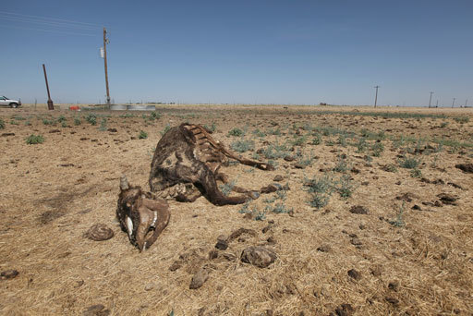

Figure 2.1  Drought causes loss of life and livelihood.

**Flooding**

**Flooding** is an abnormal rise in the water level and may result in overflowing of streams or rivers. Flood waters can destroy infrastructure, including houses, roads and water supply systems, as well as agricultural crops, which ultimately causes a shortage of food supplies in the country. Besides the destruction of property, people and animals may be killed, especially when **flash floods** occur. (A flash flood happens when rain falls so fast that the underlying ground cannot drain the water away fast enough and rivers overflow their banks. Roads can then become like rivers and if there is a lot of water it can flood buildings and carry cars away.)

Floods can cause widespread bacterial contamination of wells and surface water sources with faecal matter washed from the ground surface or from flooded latrines and sewers, resulting in the outbreak of disease. For example, cholera commonly occurs after flooding.

**Earthquake**

An earthquake can cause serious damage to infrastructure on and in the ground. Pipes and treatment plants will be destroyed by a high-magnitude earthquake and the communication systems (such as road and rail networks) often become non-functional, making the delivery of emergency water supplies difficult. Destruction during an earthquake can also cause chemical spillage at manufacturing plants and warehouses, which can lead to widespread chemical contamination of drinking water.

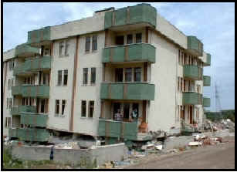

Figure 2.2  A building in Addis Ababa damaged by an earthquake.

Three possible causes of water emergencies due to humans: accidental contamination of the water supply (as in the Camelford incident); microbial contamination of water sources due to human mismanagement (such as the cholera outbreak in Haiti); deliberate poisoning of the water supply as an act of terrorism.

**Box 2.1  An example of a human-caused water emergency in the UK**

In July 1988 in Camelford, a small town of 20,000 people in south-west England, 20 tonnes of aluminium sulphate was dumped into the wrong tank at the local water treatment plant (Figure 2.3) by a chemical tanker driver who was not familiar with the plant layout and delivery procedures.Aluminium sulphate went directly into the mains water supply, and this became the worst water poisoning incident in Britain. Residents complained because the water coming out of the tap was black, and curdled the milk in their tea. One man described how his hair had stuck together after he took a bath, as if his head had been smeared with glue. Symptoms such as stomach cramp, diarrhoea, skin rashes, joint pain, sore throat, short-term memory problems and general exhaustion were reported.

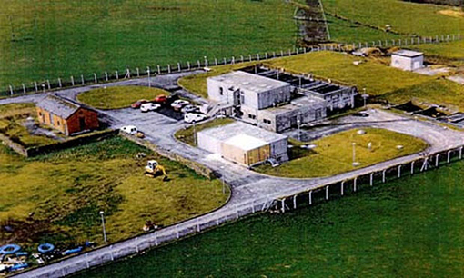

Figure 2.3  The water treatment plant at Camelford.

Aside from accidents, human neglect is the other most likely cause of a water emergency. Case Study 2.1 illustrates how neglect can lead to a water crisis, although it does not fit the definition of an emergency because it was not sudden.

**Case Study 2.1 Water supply in Harar**

Harar is a city in the eastern part of Ethiopia, 505 km from Addis Ababa. The city used to get water from Lake Alemaya (Haromaya), but since February 2004 the supply has ceased.

The water treatment plant at the lake was originally designed to serve a population of 70,000 but in 2000 the plant was supplying 160,000 people, who lived in Harar City, two small towns and at Haramaya University.

Lake Alemaya (Figure 2.4) has at its edge the town of Alemaya to the south and southwest, Haramaya University to the east, and farming communities to the north and northwest. In the mid-1980s its maximum depth was around 8 m and it covered an area of 4.72 km2. It was an attractive freshwater lake used for drinking water, irrigation, fishery and recreation. Farmers in the surrounding community used a tremendous amount of fertiliser to grow different crops, in addition to khat, and excess fertiliser used to end up in the lake. Wastes containing chemicals from the town were dumped at the shore of the lake in indiscriminate and irresponsible ways.

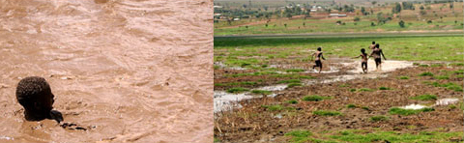

Figure 2.4  (a) Lake Alemaya before 2004; (b) the lake after 2004.

The depletion of water from the lake started slowly and no protective conservation measures were taken by anyone, although it was plain that the water level was dropping year on year.

After the water had nearly gone, the city faced a serious water shortage and water rationing was introduced. Responding to the acute water shortage in Harar, many individuals in central government and non-governmental organizations were involved in a programme to combat the emergency. Water tankers were used to transport water to the town dwellers from distant available sources (Figure 2.5). This emergency operation continued for more than a year until deep wells were dug 20 km away to supply water to the residents again.

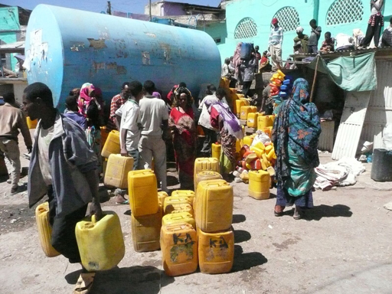

Figure 2.5  Tankered water supplies for residents of Harar in 2011.

**The possible options for safe water supply during a water emergency are:**

* + delivery of water to consumers by water tanker and/or bottles
  + treatment of the water at the household to render it safe (e.g. by boiling).

**Tanker-transported Water**

In a water-supply emergency, facilities may need to rely on a water hauler to transport water to the facility. Planning for the use of tanker-transported water involves the following steps:

• Determine if the water source being used to fill the tanker trucks is safe and from an approved source.

• Determine if the tanker being used to transport the water is appropriate for the transport of potable water. The tanker must be food grade certified, contaminant-free, and watertight.

• Ensure proper cleaning and disinfection of tanker truck.

• Isolate the building plumbing from the primary water supply.

• Make provisions to convey the water safely from the tanker trucks to the building. All hoses and other handling equipment used in the operation should meet Standard, be stored off the ground at all times, and be thoroughly flushed and disinfected before use.

**Commercially Bottled Water**

Commercially bottled water may provide the most convenient immediate source of potable water for use during an emergency. Several advantages of commercially bottled water include: a readily available source of contingency water during unforeseen emergencies, and an available higher level of water treatment (e.g., reverse osmosis, distillation) that may not be standard for tap water. However, a careful and knowledgeable review of a commercial bottler's treatment methods is necessary to ensure adequate removal of pathogens and other contaminants of concern. A disadvantage of commercially bottled water is that it cannot be made available in quantities large enough to meet all hospital needs without becoming cost-prohibitive.

**Treatment of the water at the household:**

1. The two treatment steps needed in household water treatment during a water emergency are filtration and disinfection.
2. Three options for filtration: cloth filtration, household sand filtration and ceramic filtration.

Three options for disinfection: boiling, solar disinfection and chlorination. (Other possibilities are the use of commercial products such as Bishan Gari, Aquatabs or P&G Purifier of Water).

1. Bishan Gari and P&G Purifier of Water.
2. The solids in the water should be settled out and the water boiled before consumption.

**3. You are about to set off to conduct a sanitary inspection of an abstraction point at a river.**

1. **What would you take with you?**
2. **Explain four things you will be looking for during your inspection.**

**Answer:**

**Sanitary inspection** means of identifying the hazards at a water source. Doing this at source is the most effective way of safeguarding consumers. A sanitary inspection (in this context) is a survey of the surroundings of a water source to identify possible health hazards and sources of pollution.

1. I would need to take an appropriate checklist of questions to ensure that I inspect thoroughly and don’t forget anything. I will also need a notebook and pen or pencil to record all the information I collect.

**Box 3.1  Example checklist for inspection of an abstraction point at a river**

1. Is there any human habitation upstream, polluting the source? Yes/No
2. Are there any farm animals upstream, polluting the source? Yes/No
3. Is there any crop production or industrial pollution upstream? Yes/No
4. Is there a risk of landslide or mudflow (caused by deforestation) in the catchment area? Yes/No
5. Is the intake installation unfenced? Yes/No
6. Is the intake unscreened? Yes/No
7. Does the abstraction point lack a device such as a dam so that water flows into the box at 8? Yes/No
8. Does the system require a sand or gravel filter because the water is silt-laden and can affect water treatment? Yes/No
9. If there is a filter, is it functioning badly? Yes/No
10. Is the flow uncontrolled? Yes/No

Total number of ‘Yes’ answers = contamination risk score:

9–10 = very high

6–8 = high

3–5 = intermediate

0–2 = low.

Name ______________________

Signature ______________________

Date ______________________

1. Important things to look for include the location of any latrines or other possible sources of contamination (due to farming or industrial activities) relative to the river, the possibility of any landslide or mudflow, a good solid fence, a screen on the intake, the presence of a dam, the presence of a filter and, if a filter is present, that it is operating properly, and whether there is any uncontrolled flow.

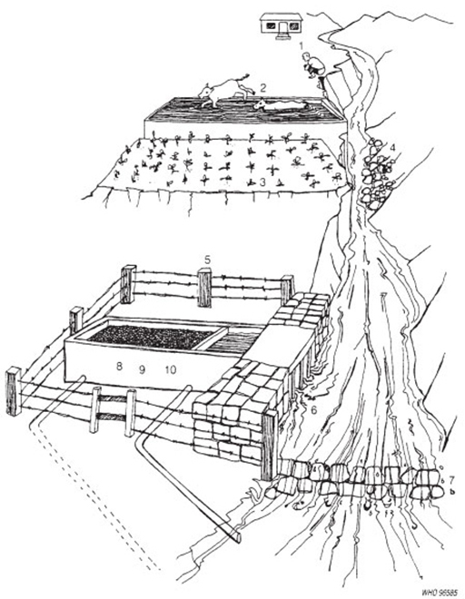

Figure 3.1  Sanitary inspection of an abstraction point at a river. (WHO, 1997)

**4. Explain briefly why a Water Safety Plan is necessary**

Answer:

A **Water Safety Plan** is a plan to ensure the safety of drinking water through a risk assessment and management process that considers all the points in water supply from the catchment to the consumer. It is a means of preventing and managing threats to a drinking water supply system, before anything goes wrong, taking into account all the stages of the supply process from the water catchment to the consumer.

By using Water Safety Plans, the quality of the water is proactively managed so that poor-quality water does not reach consumers. Water Safety Plans also help to eliminate the causes of incidents that might disrupt the delivery of safe water to consumers. **Incidents**, in the context of water supply, means emergencies such as a burst pipe.

A Water Safety Plan considers all the stages in the supply of water, and therefore it involves:

* management of the catchment to prevent contamination of the source water
* removal or elimination of contaminants during treatment of the water
* prevention of contamination of the water after treatment (during distribution, storage and handling).

**The components of a Water Safety Plan**

Water Safety Plans can vary in complexity depending on the scale and type of water supply system being considered. In general, there are ten components in a Water Safety Plan (Figure 4.1).

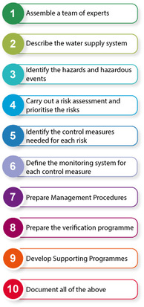

Figure 4.1 The steps in a Water Safety Plan.

**5. Distinguish between the two types of maintenance at a water utility and give reasons why one of them is better**

**Answer:**

**Maintenance** (Figure 5.1) refers to planned technical activities or activities carried out in response to a breakdown, to ensure that assets are functioning effectively, and requires skills, tools and spare parts (Carter, 2009). There are two types of maintenance:

* Corrective or breakdown maintenance: this is carried out when components fail and stop working. Breakdown is common in many utilities in Ethiopia and occurs as a result of poor preventive maintenance.
* Preventive maintenance: this is a regular, planned activity that takes place so that breakdowns are avoided. Examples of preventive maintenance would include servicing of equipment, inspecting equipment for wear and tear and replacing as necessary, cleaning and greasing moving parts of equipment, and replacing items that have a limited lifespan. Preventive maintenance is important because it ensures that the asset fulfils its service life. It also prevents crises occurring and costly repairs (in terms of time and money) being needed.

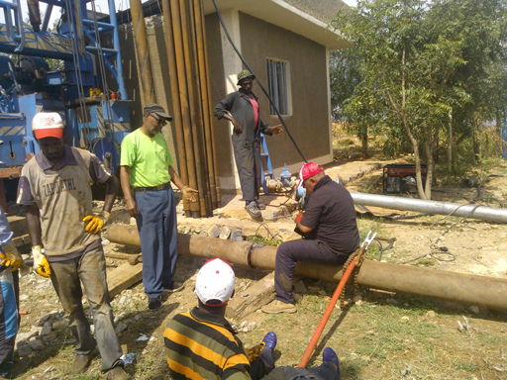

Figure 5.1 Technicians undertaking maintenance activities on a water treatment unit.

Preventive maintenance ensures that the different components of the water supply system perform correctly over their service life (their expected lifetime). This in turn avoids the occurrence of a major fault or breakdown in the water supply system that calls for corrective maintenance that is many times more expensive. In some cases, the problem may require full replacement of a costly item of equipment, which also takes a significant amount of time to achieve. As a result, the service level of the water supply system will reduce or even be interrupted over the period of maintenance, causing significant inconvenience to users and reducing the income of the water utility.

Reference:

Online Post Graduate Diploma in Water Hygiene and Sanitation (WASH)

WASH Module 4 Notes